Create a module that implements an XNOR gate.

[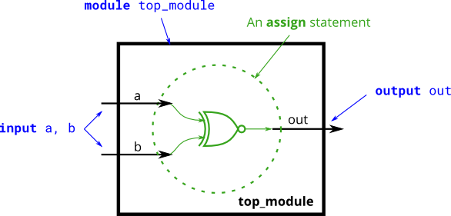](https://hdlbits.01xz.net/wiki/File:Xnorgate.png)